Public Art- Art Reflection

Art Piece name: Traveling Light  Artist: inges idee  Site: 96 Avenue NE  (Near Airport Tr. and Deerfoot Tr. interchange)  Website  Video  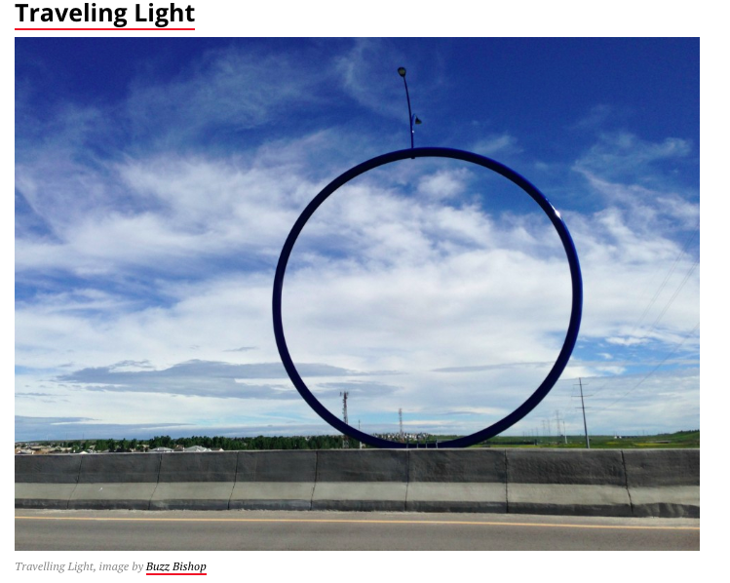 | Art Piece name: Wonderland  Artist: Jaume Plensa  Site: Bow Tower, Downtown Calgary  Website  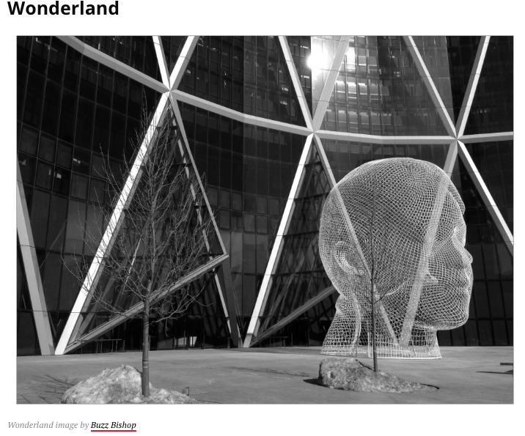
Public Art- Art Reflection

Art Piece name: Chinook Arc  Artist(s): Joe O’Connell and Blessing Hancock (Creative Machines – Technical Consultant)  Site: Barb Scott Park (12th Ave. and Ninth St. S.W.)  Website with Video  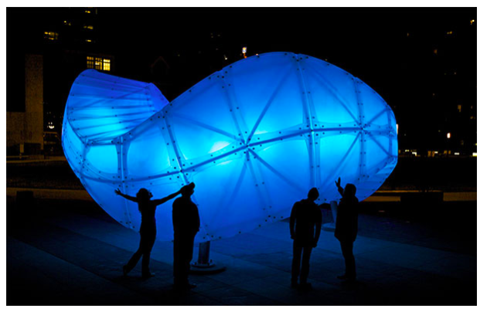 | Art Piece name: Ascend  Artist(s): Haddad/ Drugan  Site: YMCA at Rocky Ridge  Website  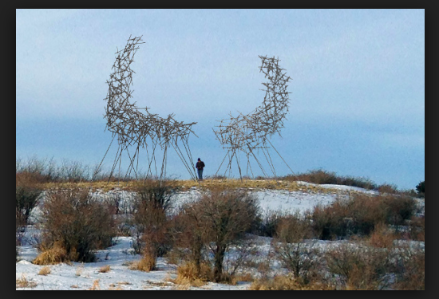

Public Art Reflection Questions

- What do you think the art piece means?

- What makes this art?

3. Do you like the piece? Why or why not?

4. Why do you think they chose this piece for this space/location?

5. How do you think the artist came up with this idea? What is the story behind the piece? What is its purpose?

6. What does this piece make you think of when you look at it? Why?

7. What do you think the artist made this piece out of? Why did they choose that material to create this piece with?

8. How much money do you think this piece cost? What do you think the value of it is? Was it worth the money in your opinion? Why or why not?

9. Do people actually stop and look at this? Why or why not?

Comparison Questions

- What are the similarities between the two pieces of art?
- What are the differences between the two pieces of art?
- Which one do you prefer and why?

